UNIVERSITY OF CEBU - BANILAD
COLLEGE OF COMPUTER STUDIES
INTPROG FINAL PROJECT PROPOSAL TEMPLATE

Phase 1 - Analysis, Design and Local Prototype
Use this document as the required template for your Final Project Proposal. Replace the instructional prompts with your own content. Your proposal must be based on your assigned case study and must describe the solution you intend to develop. Do not copy the case study description as your proposal.

STUDENT AND PROJECT INFORMATION
Student Name | Nichole Kaye N. Orador
Student ID | 24248916
Section / Schedule | BSITS SE - TTH 3:00 PM - 4:30 PM
Assigned Case Study No. | 32
Assigned Case Study Title | Water Refill Delivery Manager
Proposed Application Title | RefillTrack

1. CASE ANALYSIS
Explain the assigned real-world situation in your own words. Your discussion should show that you understand the problem before proposing a technical solution.

1.1 Background / Current Situation
A local water-refilling station accepts delivery orders from customers through phone calls and text messages. Station staff write down or remember each order, group them by area or by time, and then pass them to delivery personnel. The same few people prepare the gallons, decide who delivers, and follow up on whether the order reached the customer.

1.2 Primary Problem
The station has no single, reliable record of its orders and no clear way to see where each order currently stands. Because orders are tracked manually, staff cannot easily tell which orders are still waiting, which are already prepared, which are on the road, and which were already delivered.

1.3 Affected Stakeholders
Stakeholder | How They Are Affected
Customers | Orders may be forgotten, delayed, or duplicated, and they cannot easily confirm whether their order is on its way.
Station staff | They spend time re-checking notes and messages, and manually grouping orders, which invites mistakes.
Delivery personnel | They may not know exactly which orders are assigned to them or which have already been completed.

1.4 Problems or Limitations of the Current Process
- Orders received by call and message are scattered across notes, chat threads, and memory.
- There is no fixed workflow from preparation to delivery, so steps can be skipped or repeated.
- Completed orders are mixed with orders that are still active, making the current work hard to see.
- Manual grouping of orders is slow and easily leads to missed or double deliveries.
- There is no record of which rider was responsible for which order.

2. PROPOSED MOBILE SOLUTION
RefillTrack is an Android application that gives the station one organized list of all customer orders, each with a single status that moves through a fixed workflow. Staff encode every order once, as soon as it is received by call or message. The order is then advanced step by step: Pending, Preparing, Out for Delivery, and finally Delivered. An order may be Cancelled only while it is still Pending.
The app separates the work into two views. The Active tab shows orders that still need action, while the History tab shows Delivered and Cancelled orders, so completed orders are kept apart from active deliveries. Riders log in and see only the orders assigned to them, and mark each one as Delivered once the customer has received it.
A mobile application is appropriate because staff and riders are often away from a desk, and every person already carries a phone. Status updates made by one person can be seen by the others in real time through Firebase.

3. TARGET USERS / USER ROLES
User / Role | Description | Main Responsibilities / Allowed Actions
Staff (Admin) | Station employee who receives calls and messages and manages the orders. | Log in and log out; add orders; view Active and History orders; set status to Preparing; assign a rider and set Out for Delivery; cancel Pending orders; search and filter orders.
Rider | Delivery personnel who bring the filled gallons to customers. | Log in and log out; view only the orders assigned to them; mark an assigned order as Delivered.

4. FUNCTIONAL REQUIREMENTS
ID | Functional Requirement | Related User / Role
FR-01 | The system shall allow users to log in with a registered email and password and open the screen that matches their role. | Staff, Rider
FR-02 | The system shall allow a logged-in user to log out, end the session, and return to the Login screen. | Staff, Rider
FR-03 | The system shall allow Staff to add a new order with customer name, phone number, address, and number of gallons, saved with the status Pending. | Staff
FR-04 | The system shall display all Active orders (Pending, Preparing, Out for Delivery) in the Active tab. | Staff
FR-05 | The system shall display all Delivered and Cancelled orders in a separate History tab. | Staff
FR-06 | The system shall allow Staff to change an order from Pending to Preparing. | Staff
FR-07 | The system shall allow Staff to assign a rider to an order and change its status to Out for Delivery. | Staff
FR-08 | The system shall display to a Rider only the orders assigned to that Rider that are Out for Delivery. | Rider
FR-09 | The system shall allow a Rider to mark an assigned order as Delivered. | Rider
FR-10 | The system shall allow Staff to cancel an order that is still Pending. | Staff
FR-11 | The system shall allow Staff to search orders by customer name and filter them by status. | Staff
FR-12 | The system shall show the full details of an order, including its current status and assigned rider. | Staff, Rider

5. BUSINESS RULES AND VALIDATION REQUIREMENTS
ID | Business Rule / Validation | Reason / Expected Behavior
BR-01 | Order status must follow this sequence only: Pending, Preparing, Out for Delivery, Delivered. | Keeps a clear preparation-to-delivery workflow. Steps cannot be skipped and an order cannot move backward.
BR-02 | A rider must be assigned before an order can be set to Out for Delivery. | Every delivery must have a responsible rider. The system blocks the update and shows a message if no rider is selected.
BR-03 | Only Staff can create, prepare, assign, or cancel orders. Only the assigned Rider can mark an order Delivered. | Protects records by limiting each action to the proper role and record owner.
BR-04 | An order can be cancelled only while its status is Pending. | Once preparation starts, cancellation is no longer allowed. The Cancel button is hidden or disabled afterward.
BR-05 | Delivered and Cancelled orders are locked and appear only in the History tab. | Separates completed orders from active deliveries and prevents editing finished records.
BR-06 | Customer name, phone number, address, and gallons are required. | An order cannot be saved with empty fields; the app shows an error on the missing field.
BR-07 | Phone number must contain exactly 11 digits. | Ensures the customer can be contacted by the rider or staff.
BR-08 | Number of gallons must be a whole number from 1 to 50. | Prevents zero, negative, or unrealistic quantities.
BR-09 | Email and password are required to log in, and they must match a registered account. | If a field is empty or the credentials are wrong, the app shows an error message and the user stays on the Login screen.
BR-10 | Only logged-in users can open the app screens. After logout, the session ends and pressing Back cannot reopen a previous screen. | Protects order records from unauthorized access, especially on a shared phone.

6. PROPOSED SCREENS
No. | Screen Name | Purpose | Primary User(s)
1 | Login | Authenticate the user with email and password and send them to the correct screen based on role. | Staff, Rider
2 | Dashboard (Active | History) | Show Active and History order lists with search and status filter; includes the Logout button. | Staff
3 | Add Order | Encode a new customer order with validation. | Staff
4 | Order Details | Show full order information; update status, assign rider, or cancel (Staff); mark Delivered (Rider). | Staff, Rider
5 | My Deliveries | List only the orders assigned to the logged-in Rider; includes the Logout button. | Rider

7. NAVIGATION / SCREEN FLOW
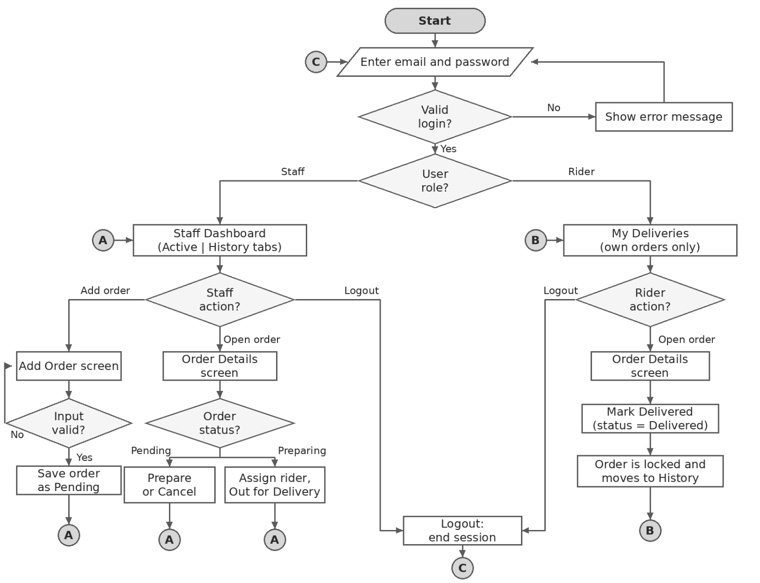

8. DATA DESIGN
Data Model / Entity | Important Fields | Purpose | Relationship / Reference
User | uid, name, email, role (staff or rider) | Represents a person who can log in to the app. | uid is linked to Firebase Authentication
Order | orderId, customerName, phone, address, gallons, status, riderId, createdAt | Represents one customer delivery order and its current status. | riderId refers to User.uid (empty until assigned)

9. PROPOSED FIREBASE STRUCTURE
Cloud Firestore is used with two collections. Active and History are not separate collections; they are two queries on the status field of the orders collection.
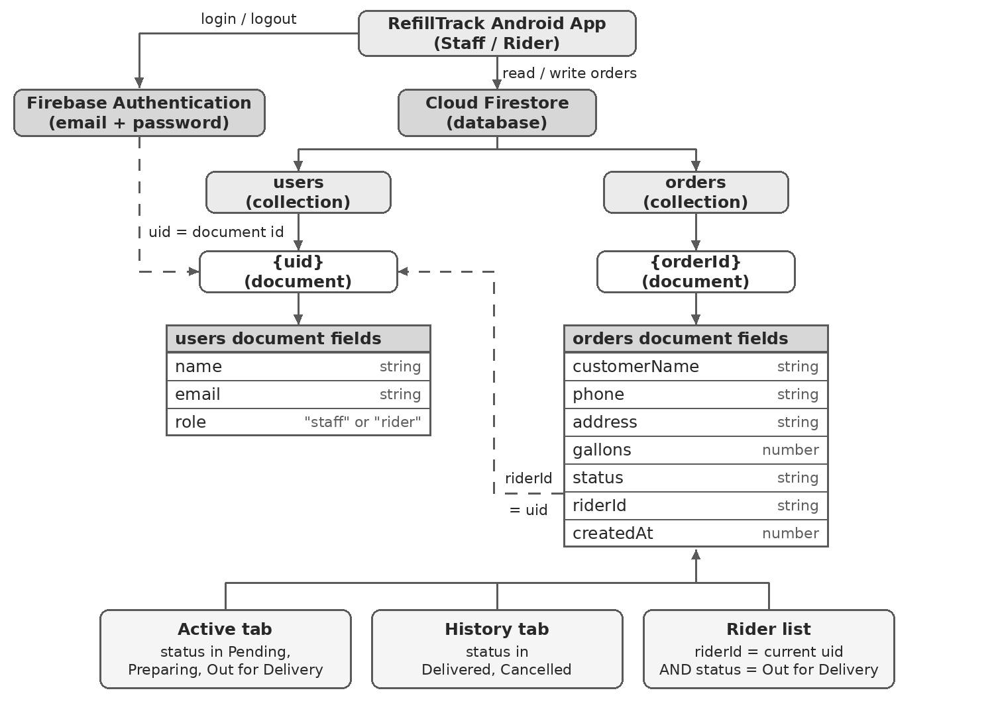

10. INITIAL WIREFRAMES
Provide simple wireframes for the major screens. Wireframes may be hand-drawn and scanned/photographed clearly, or created digitally. Focus on layout, controls, information, and navigation rather than visual decoration.

Wireframe 1
Screen Name: Login (Staff / Rider)
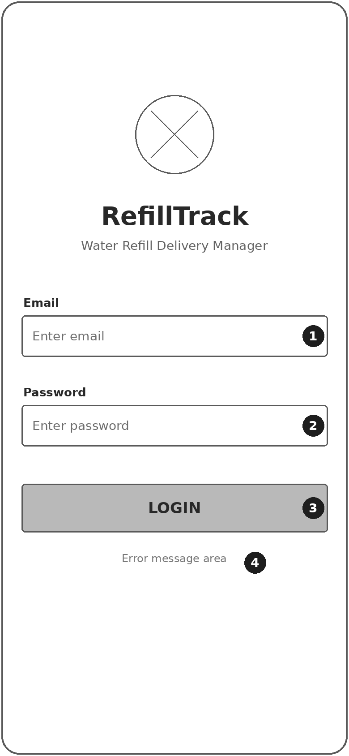 | User story: As a staff member or rider, I want to log in with my email and password so that I only see the screens and orders for my role.
  No. | Control | What it does
  1 | Email field | Type the registered email. Required.
  2 | Password field | Type the password. Required; characters are hidden.
  3 | LOGIN button | Checks the account. If valid, opens the Staff Dashboard (Staff) or My Deliveries (Rider). If not, stays on this screen.
  4 | Message area | Shows "Please fill in all fields" or "Invalid email or password".

Wireframe 2
Screen Name: Dashboard (Staff)
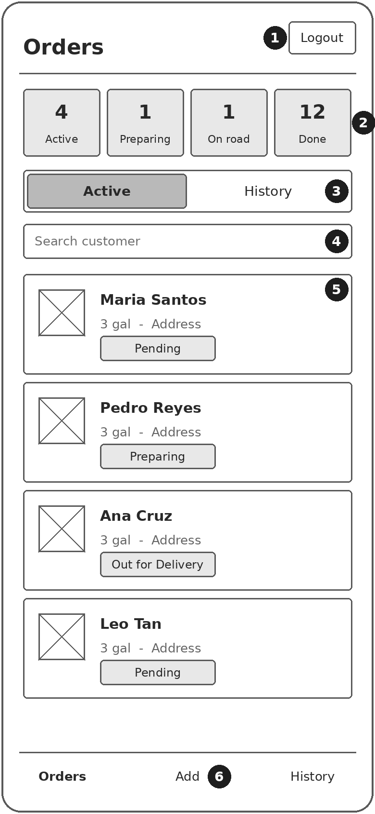 | User story: As a staff member, I want to see active orders and completed orders separately so that I know which orders still need action.
  No. | Control | What it does
  1 | Logout | Ends the session and returns to the Login screen.
  2 | Summary boxes | Show the number of Active, Preparing, On road, and Done orders (view only).
  3 | Active | History switch | Active lists Pending, Preparing, and Out for Delivery orders. History lists Delivered and Cancelled orders.
  4 | Search customer | Filters the list by customer name as the staff types.
  5 | Order card | Tap to open Order Details. The chip shows the current status.
  6 | Add (bottom bar) | Opens the Add Order screen.

Wireframe 3
Screen Name: Add Order (Staff)
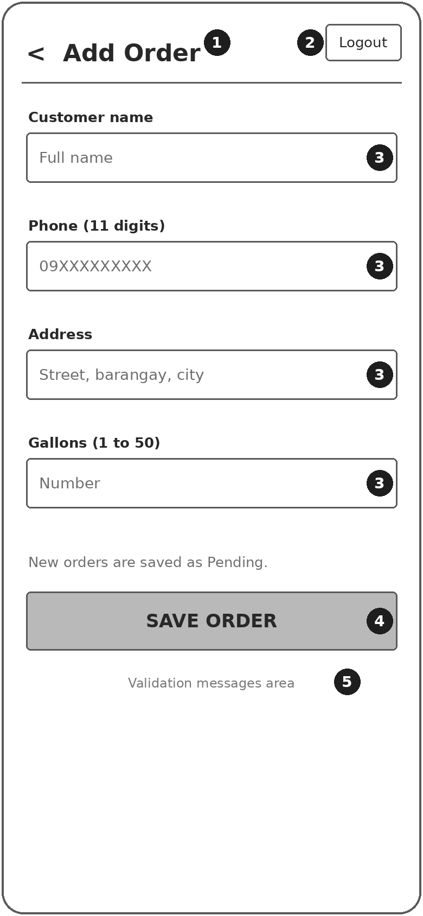 | User story: As a staff member, I want to encode a call or message order so that it is saved in one place with the status Pending.
  No. | Control | What it does
  1 | Back | Returns to the Dashboard without saving.
  2 | Logout | Ends the session and returns to the Login screen.
  3 | Input fields | Customer name, phone (11 digits), address, and gallons (1 to 50). All are required.
  4 | SAVE ORDER | Validates the fields. If valid, saves the order as Pending and returns to the Dashboard.
  5 | Message area | Shows errors such as "Phone must be 11 digits".

Wireframe 4
Screen Name: Order Details (Staff / Rider)
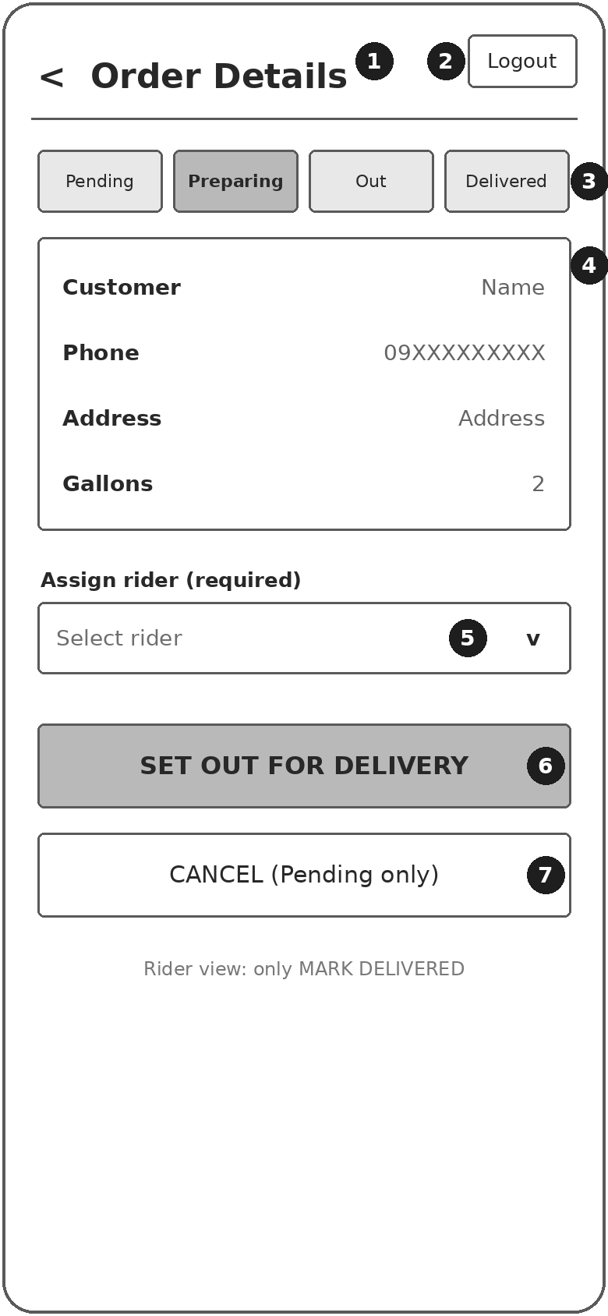 | User story: As a staff member, I want to move an order one step at a time and assign a rider so that the workflow is followed. As a rider, I want to open my assigned order and mark it Delivered.
  No. | Control | What it does
  1 | Back | Returns to the previous screen.
  2 | Logout | Ends the session and returns to the Login screen.
  3 | Status bar | Shows the current step: Pending, Preparing, Out for Delivery, Delivered (view only).
  4 | Order information | Customer, phone, address, and gallons (view only).
  5 | Assign rider | Staff picks a rider. Required before the order can be set to Out for Delivery.
  6 | Action button | Staff: Pending shows START PREPARING; Preparing shows SET OUT FOR DELIVERY. Rider: shows MARK DELIVERED. Moves one step only.
  7 | CANCEL | Staff only. Enabled only while the order is Pending. Delivered and Cancelled orders are locked.

Wireframe 5
Screen Name: My Deliveries (Rider)
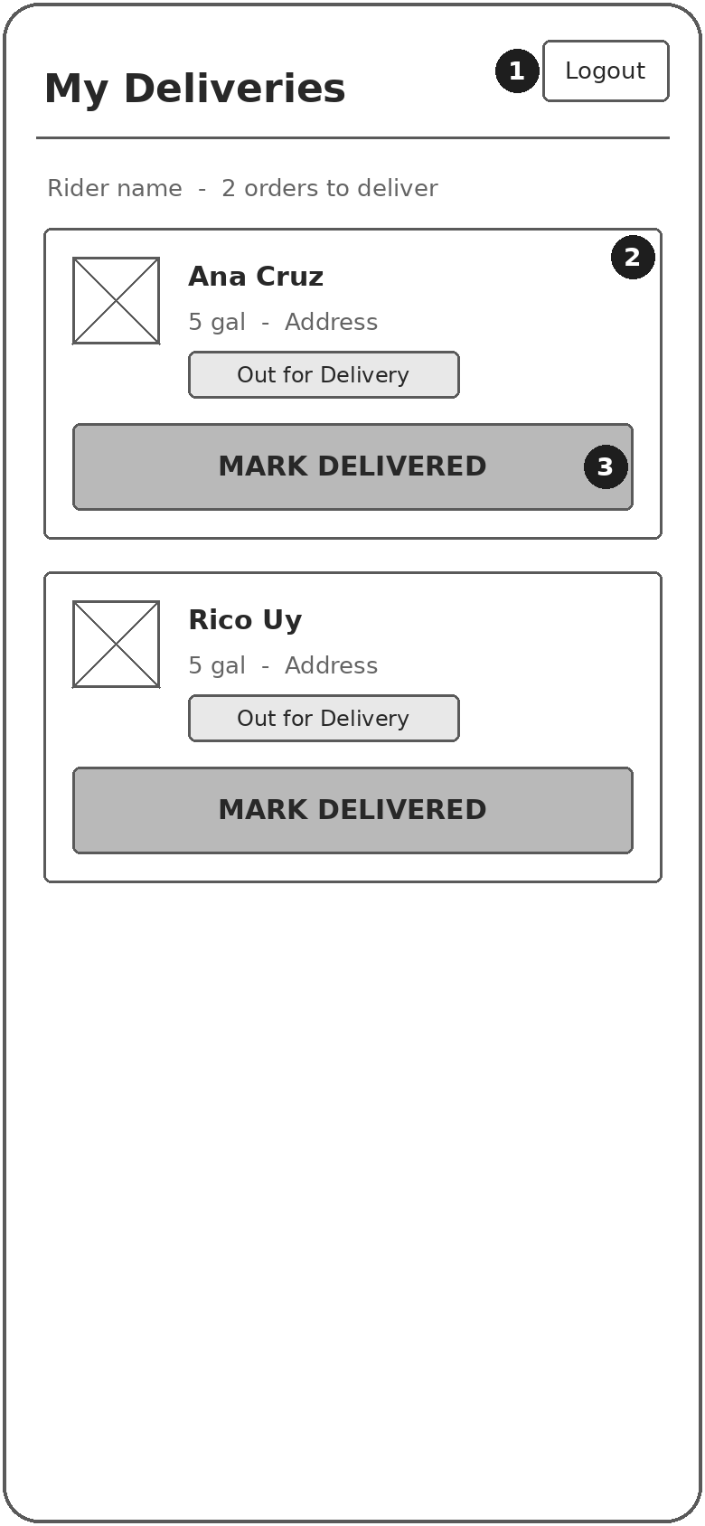 | User story: As a rider, I want to see only the orders assigned to me so that I know where to deliver and mark each one when the customer has received it.
  No. | Control | What it does
  1 | Logout | Ends the session and returns to the Login screen.
  2 | Order card | Shows customer, gallons, address, and status. Lists only this rider's Out for Delivery orders.
  3 | MARK DELIVERED | Sets the order to Delivered, removes it from this list, and moves it to History for the Staff.

11. SCOPE AND LIMITATIONS

11.1 Project Scope
- Two user roles: Staff and Rider, with email/password login, role-based screens, and logout.
- Encoding of customer orders received by call or message.
- Order workflow: Pending, Preparing, Out for Delivery, Delivered, with cancellation of Pending orders.
- Rider assignment and a rider-only delivery list.
- Separation of Active orders and History (Delivered and Cancelled).
- Search by customer name and filter by status.

11.2 Limitations / Exclusions
- No customer app or customer login; orders are encoded by Staff.
- No online payment, billing, or receipts.
- No GPS tracking, maps, or route optimization.
- No push notifications or SMS integration.
- No inventory or stock tracking of gallons or containers.
- The app requires an internet connection once Firebase is integrated.

12. PHASE 1 IMPLEMENTATION PLAN
Phase 1 Item | Planned Implementation | Status
Android project setup | Create a Kotlin project in Android Studio, set up ViewBinding, and confirm it builds and runs on the laboratory computer. | Not Started
Major screens | Create the five screens: Login, Dashboard, Add Order, Order Details, and My Deliveries. | Not Started
Navigation | Use Intents to move between screens; Login opens Dashboard or My Deliveries by role; the Logout button returns to Login and clears the previous screens; Dashboard uses two tabs (Active and History). | Not Started
Data passing | Pass the selected order to Order Details through Intent extras (id, name, phone, address, gallons, status). | Not Started
Kotlin data class/model | Create data class Order(id, customerName, phone, address, gallons, status, riderId) and a list of allowed statuses. | Not Started
RecyclerView / list | Create one RecyclerView with an adapter that shows the order name, gallons, and status; reused for Active, History, and My Deliveries. | Not Started
Mock/local sample data | Use hard-coded sample accounts (one staff, one rider) for the local login check, and a local mutableListOf<Order>() with sample orders in different statuses; Next Status updates the list and the lists refresh. Firebase comes in the next phase. | Not Started

13. STUDENT DECLARATION
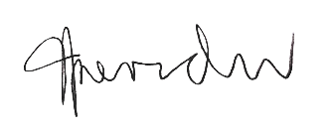
I understand that this proposal defines the initial scope of my INTPROG Final Project. I am responsible for understanding and defending the proposed solution and all code that I submit. Major changes to the approved scope or case-study solution must be discussed with the instructor.
Student Signature: _______________________________ Date: October 27, 2026
Instructor Review: ☐ APPROVED ☐ FOR REVISION
Instructor Remarks: ________________________________________________________________________________
_________________________________________________________________________________________________

